**A2 - UI - Calculator**

Esraa Abdelmoein

2025-09-14

Mobile Application Development– Android

Russel Shanahan

Part 1: Message App: Here is my Github URL: <https://github.com/EsraaAbdelmoein/Android_part1_Message-App.git>

1. **Make the DisplayMessageActivity background change to the colour entered in the text message using 5 different colours.**

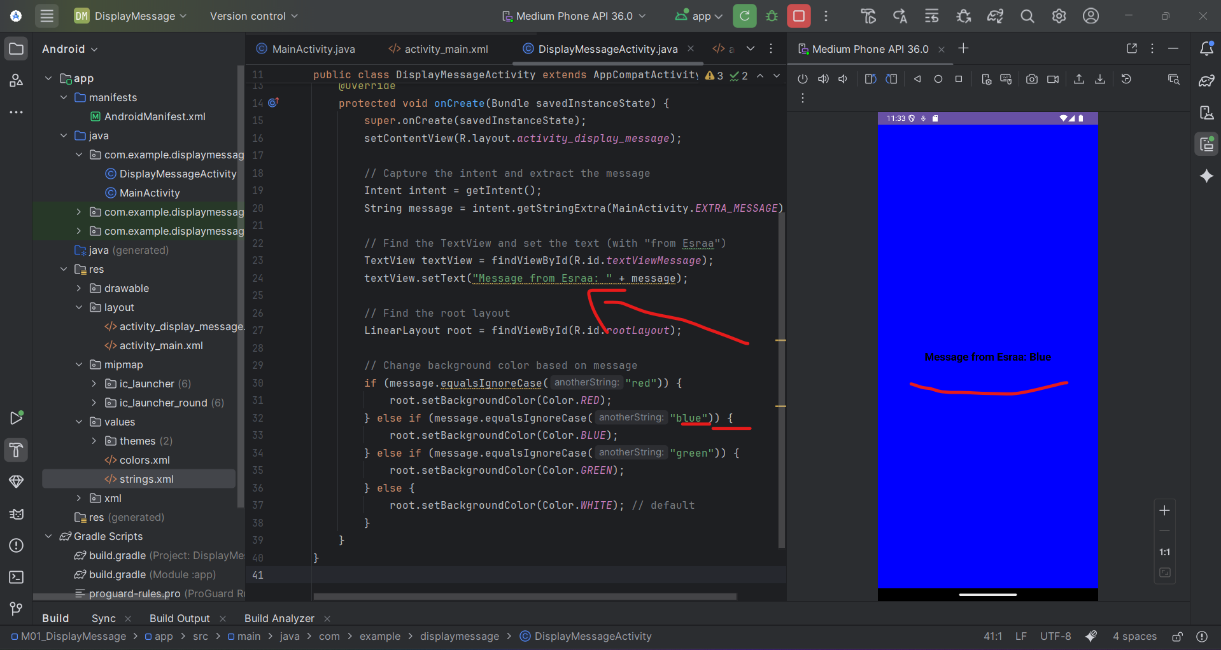

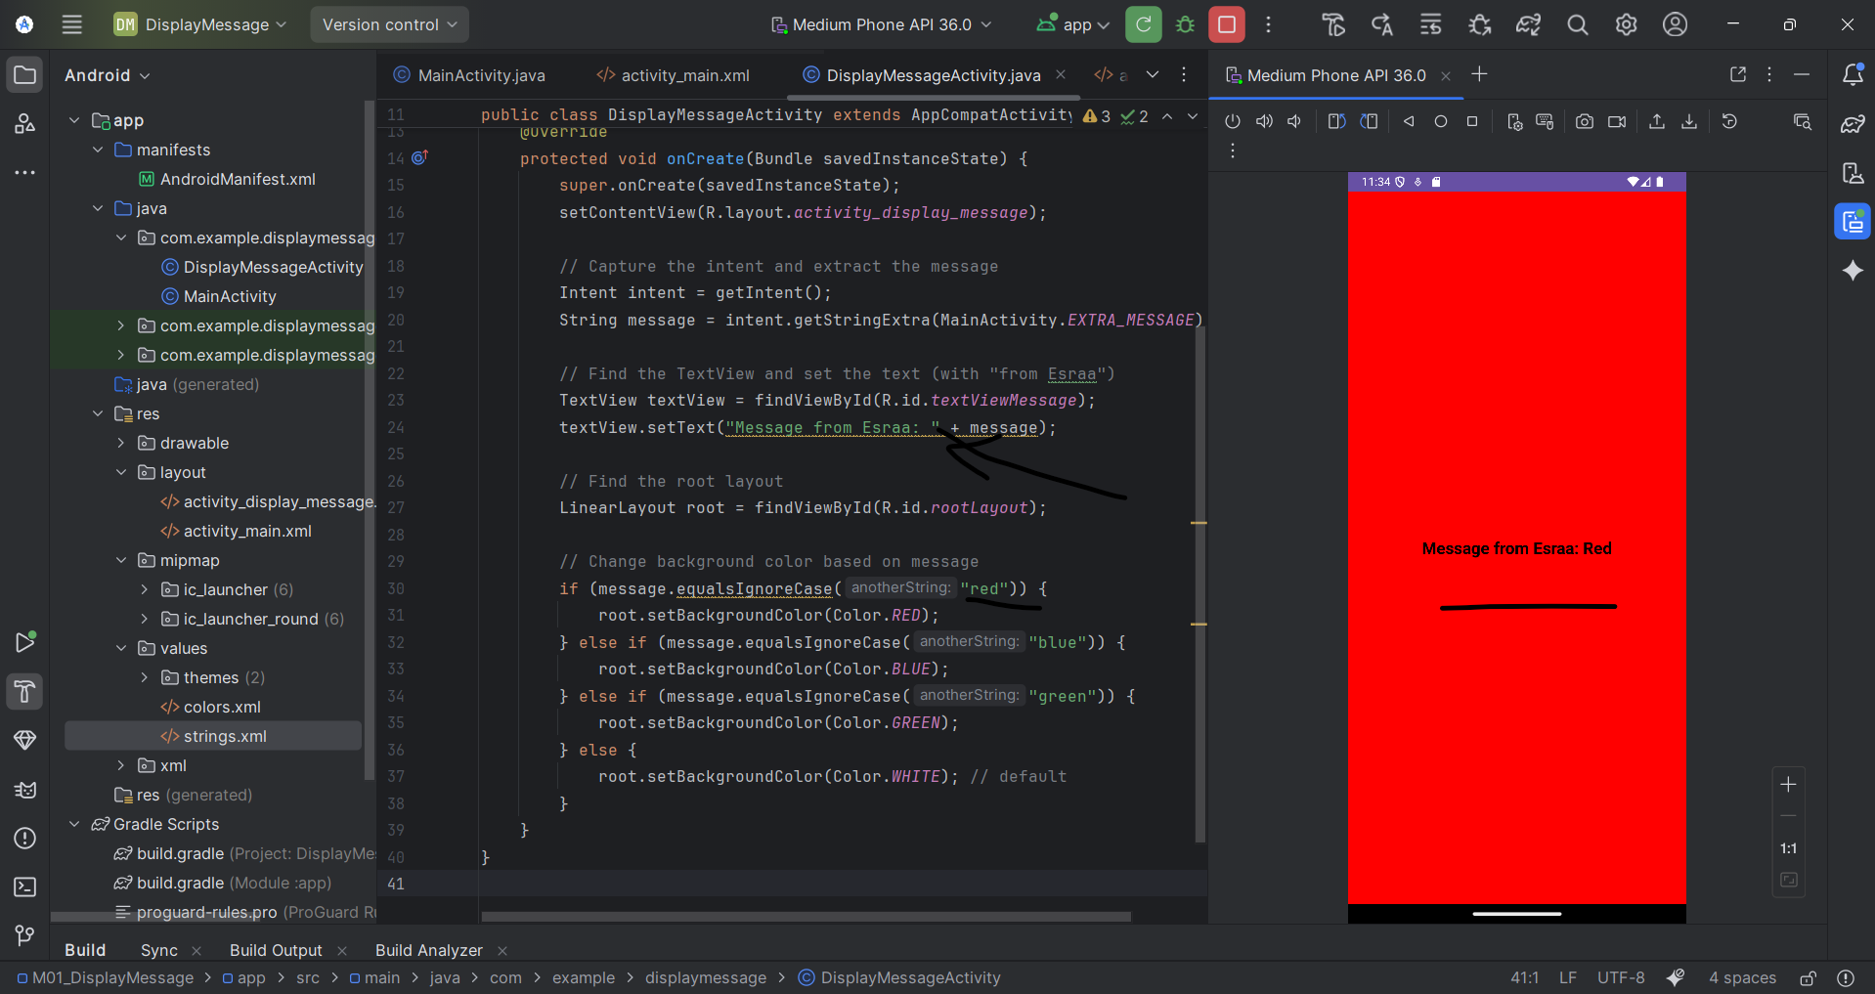

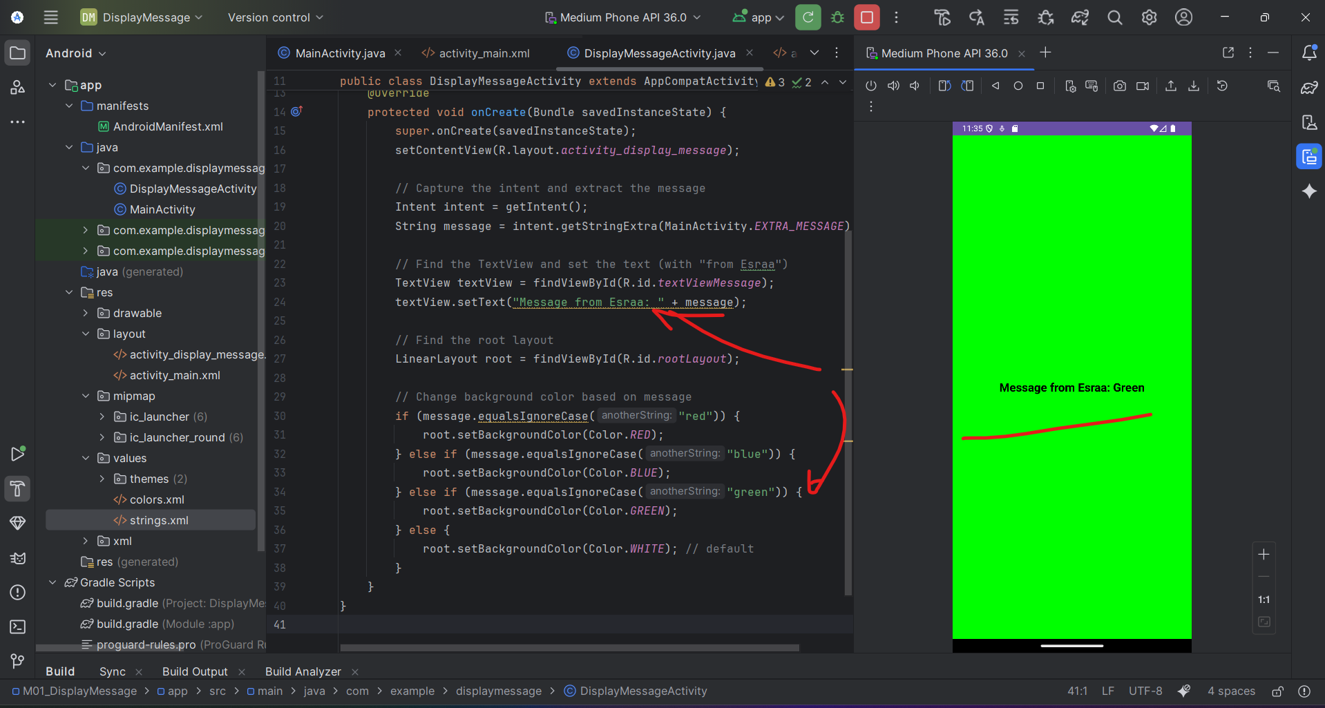

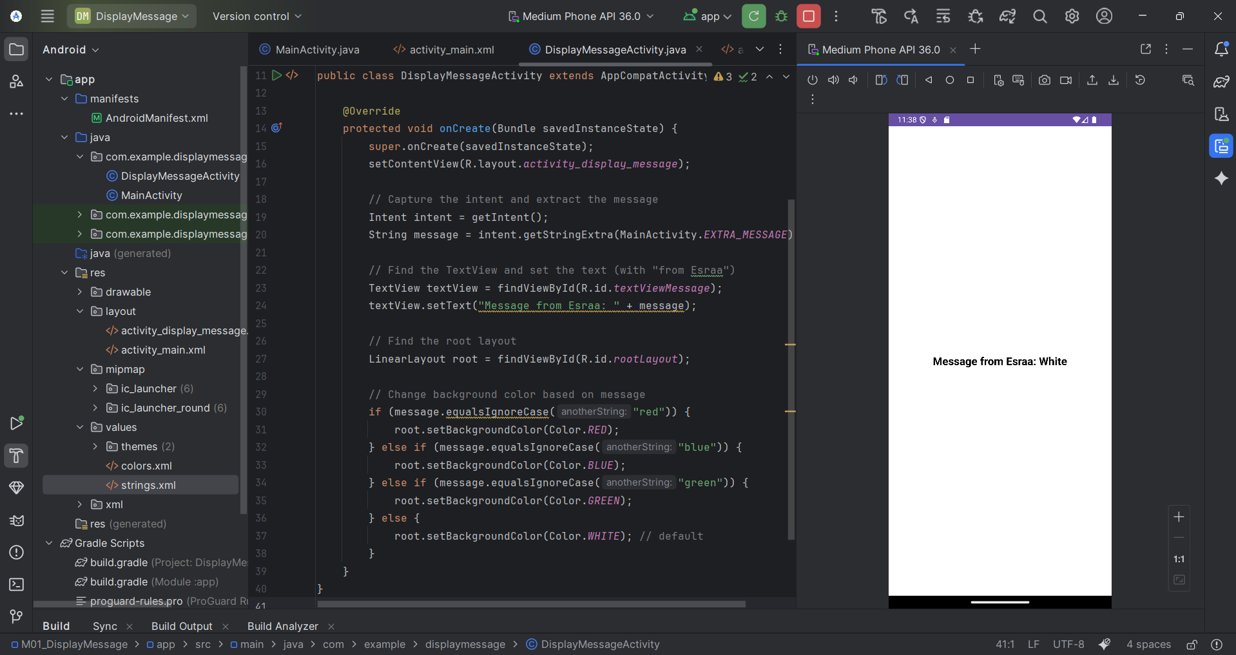

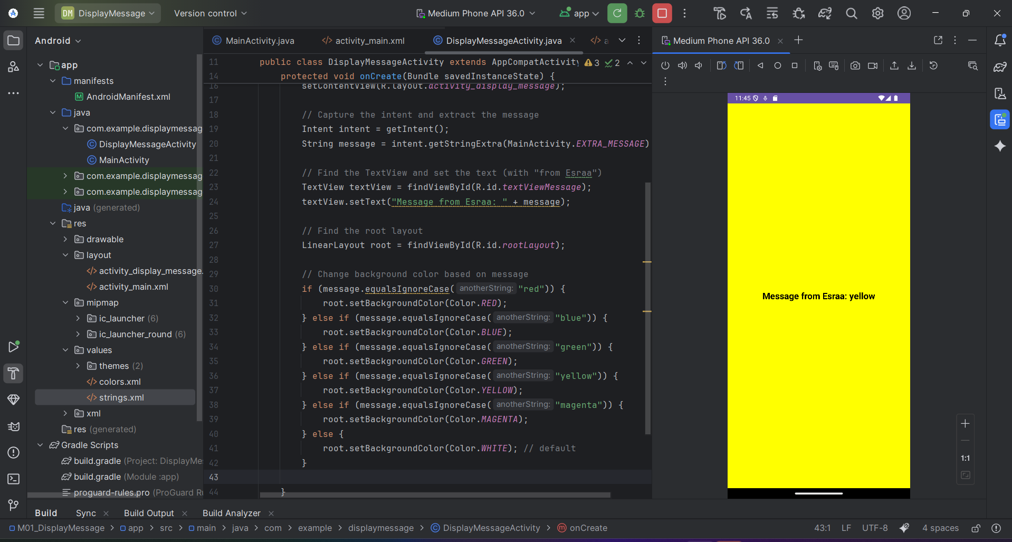

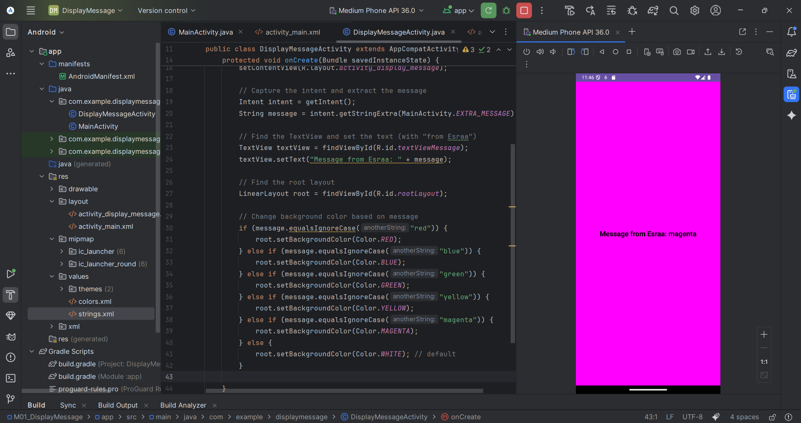

1. **Add your own message to the message sent to the activity, and display the whole message.**

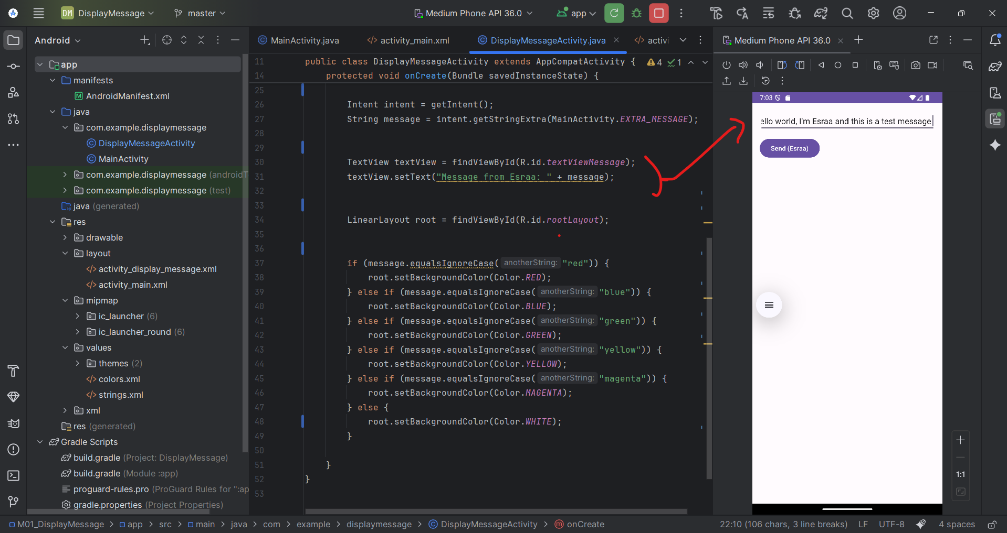

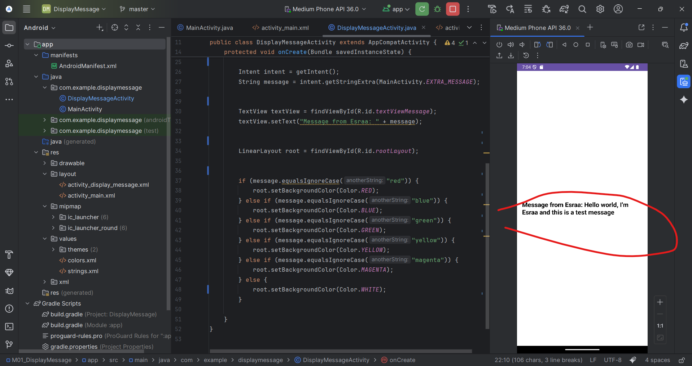

**3/ Add a delay in the DisplayMessageActivity onCreate() method...see if you can get "Skipped 61 frames!  The application may be doing too much work on its main thread.".**

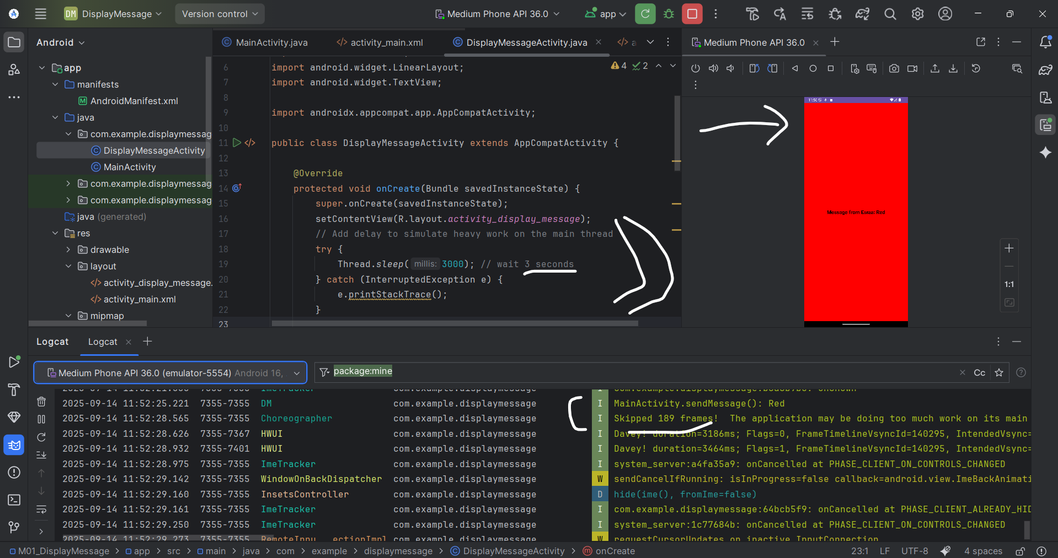

1. Why do you get the error?

**Because, i added a delay (Thread.sleep) inside onCreate(), the app blocked the main UI thread. When the main thread is blocked, Android cannot refresh the screen, so it skips frames**

1. How could you avoid it?

**Don’t put heavy work or delays on the main UI thread. Instead, use a background thread (for example: Handler, AsyncTask, or Thread) so the UI can still update smoothly**

1. What is the effect on usability of an Android App.?

**The app feels slow and frozen to the user. It doesn’t respond smoothly, which makes the app hard and frustrating to use**

1. **Change the position of the "Send" button (use the design view and drag and drop it somewhere else on the screen)**

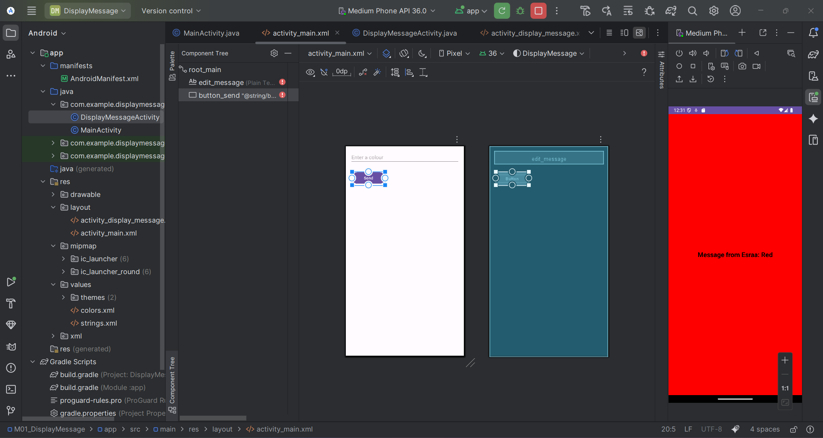

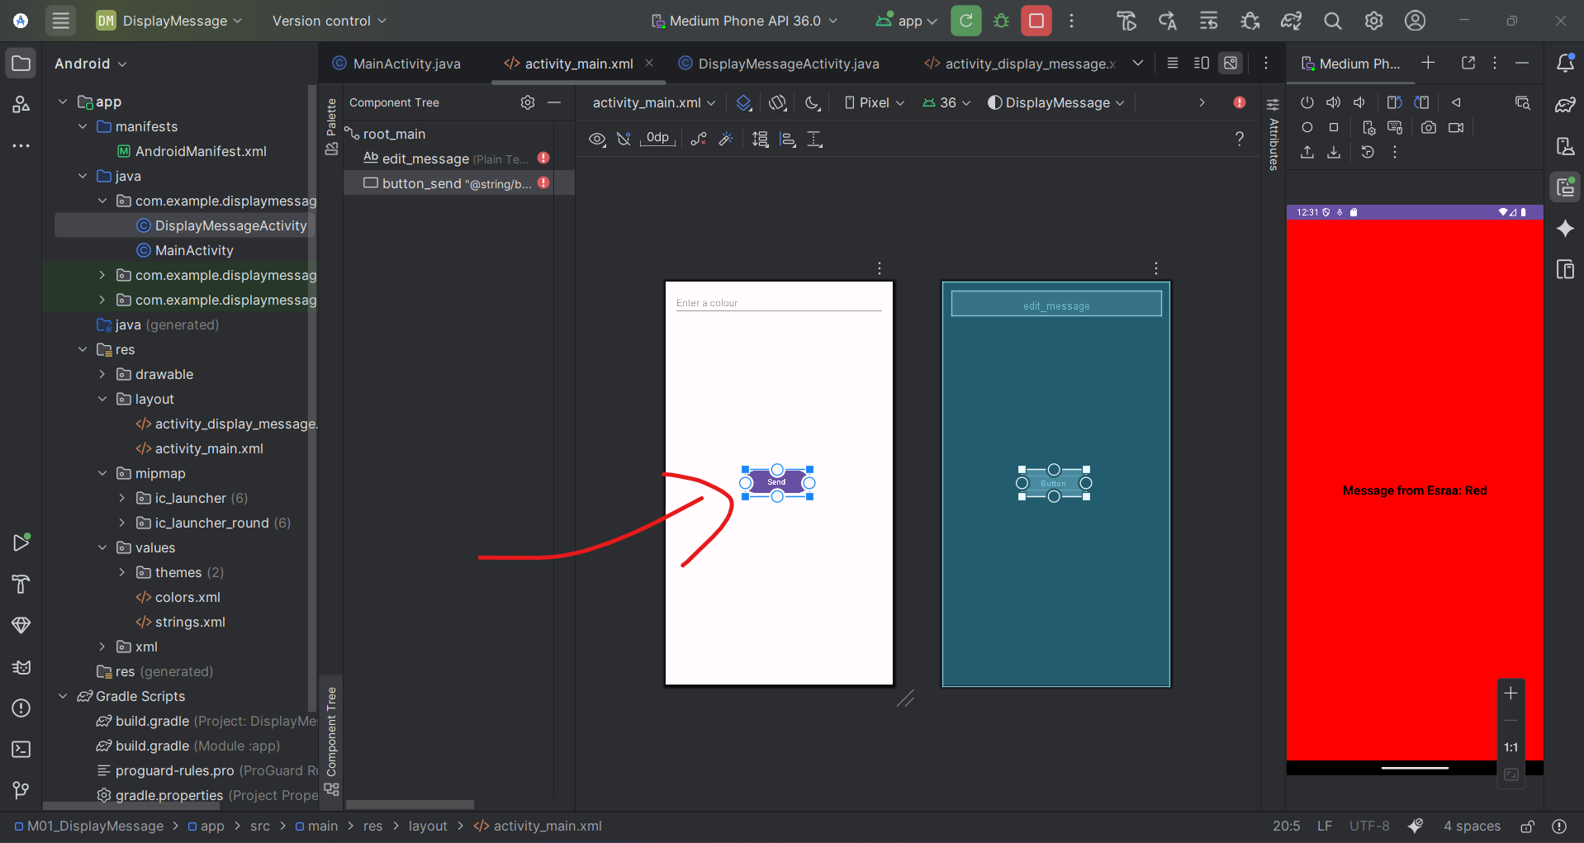

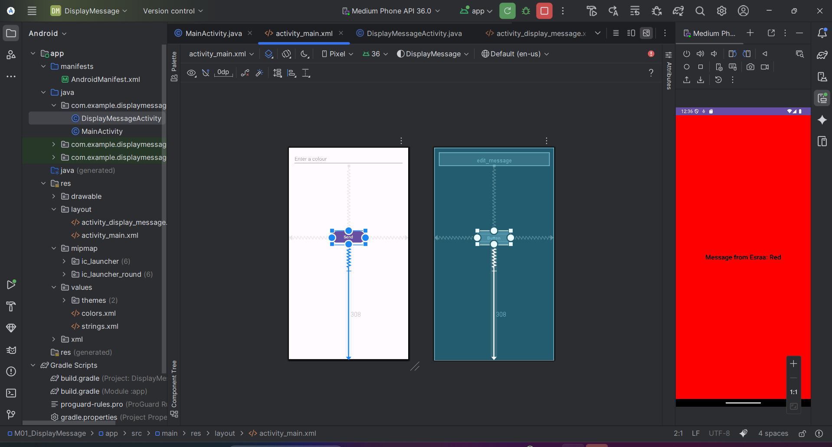

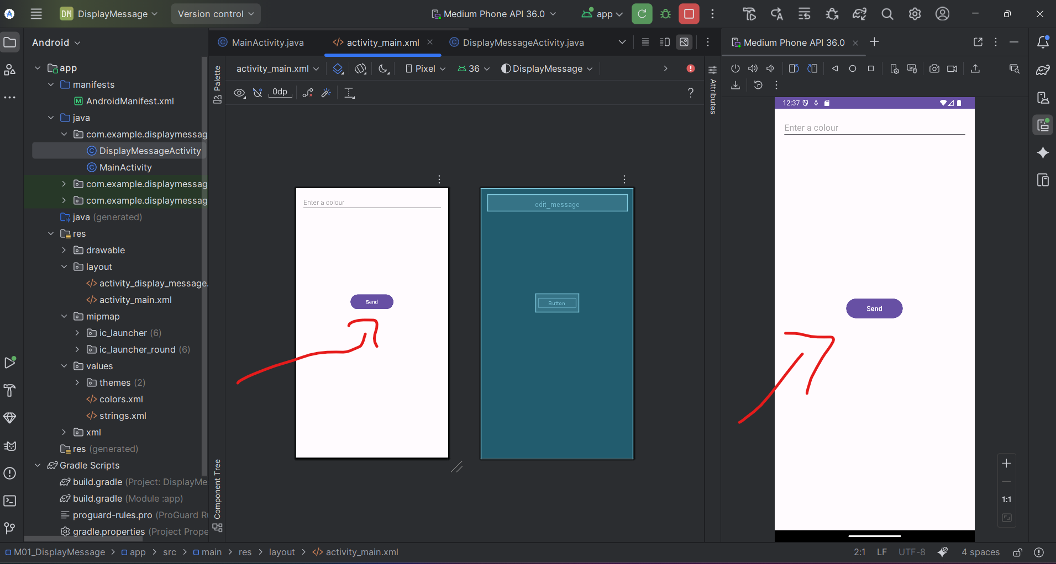

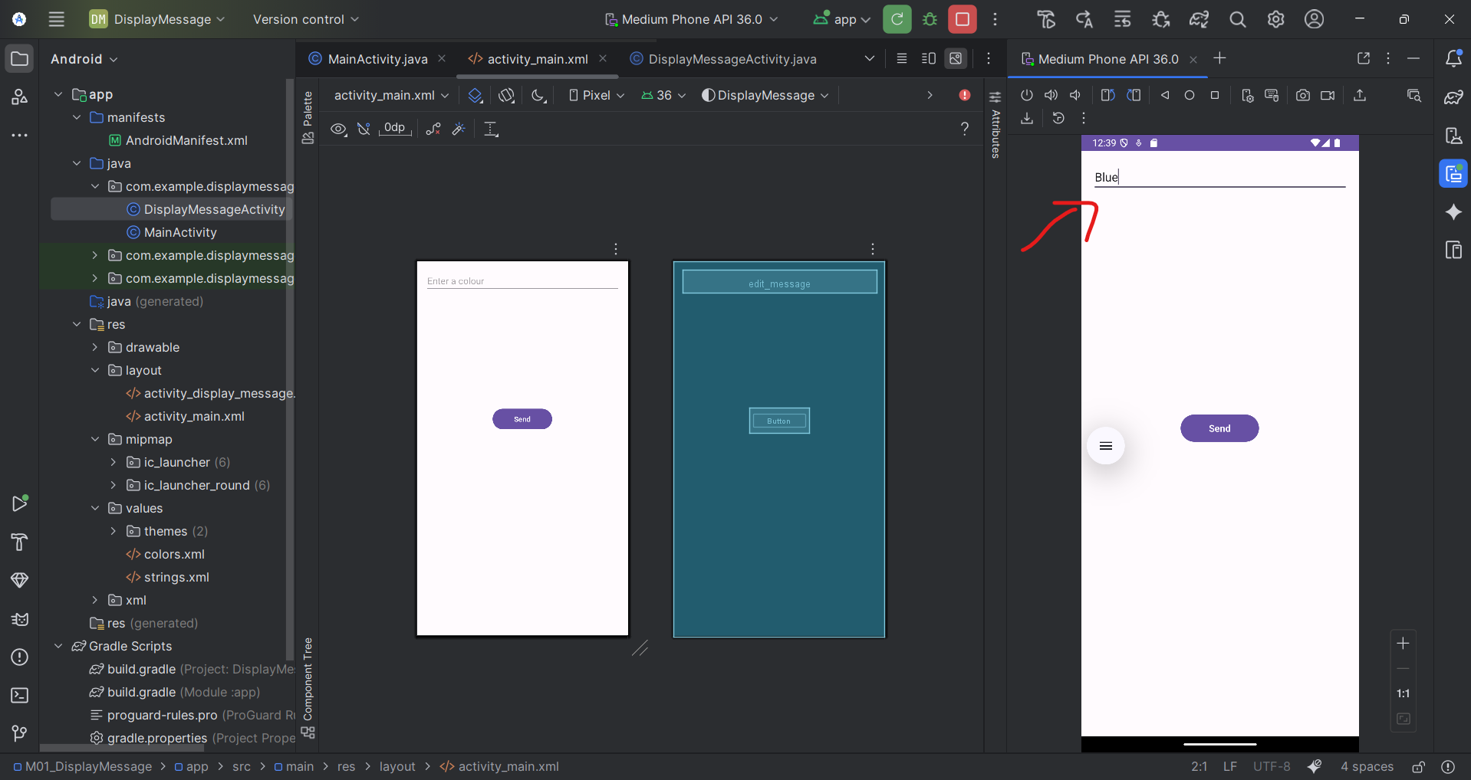

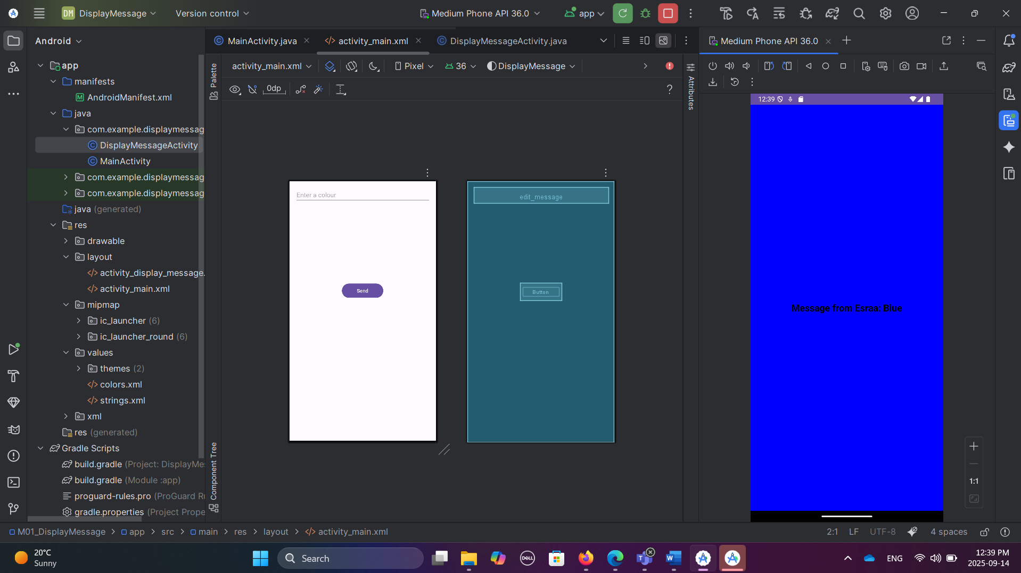

1. **Change the text in the "Send" button to something with your name in it.**

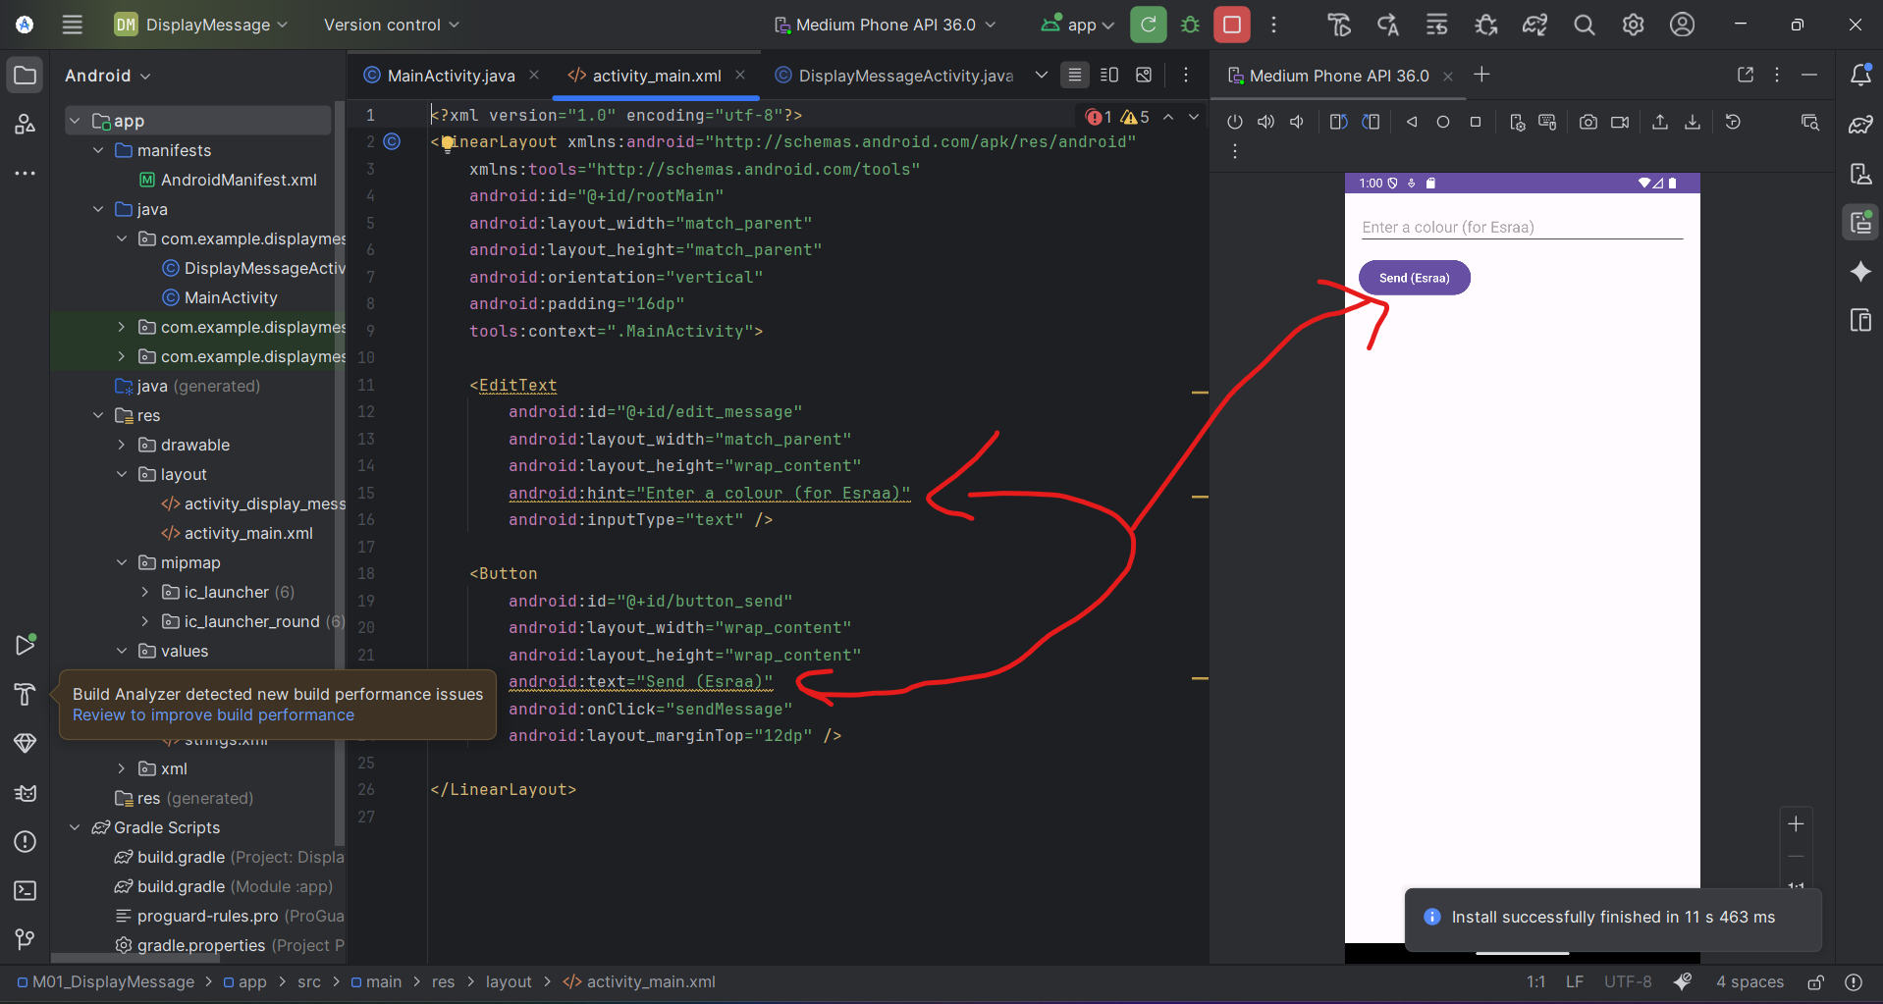

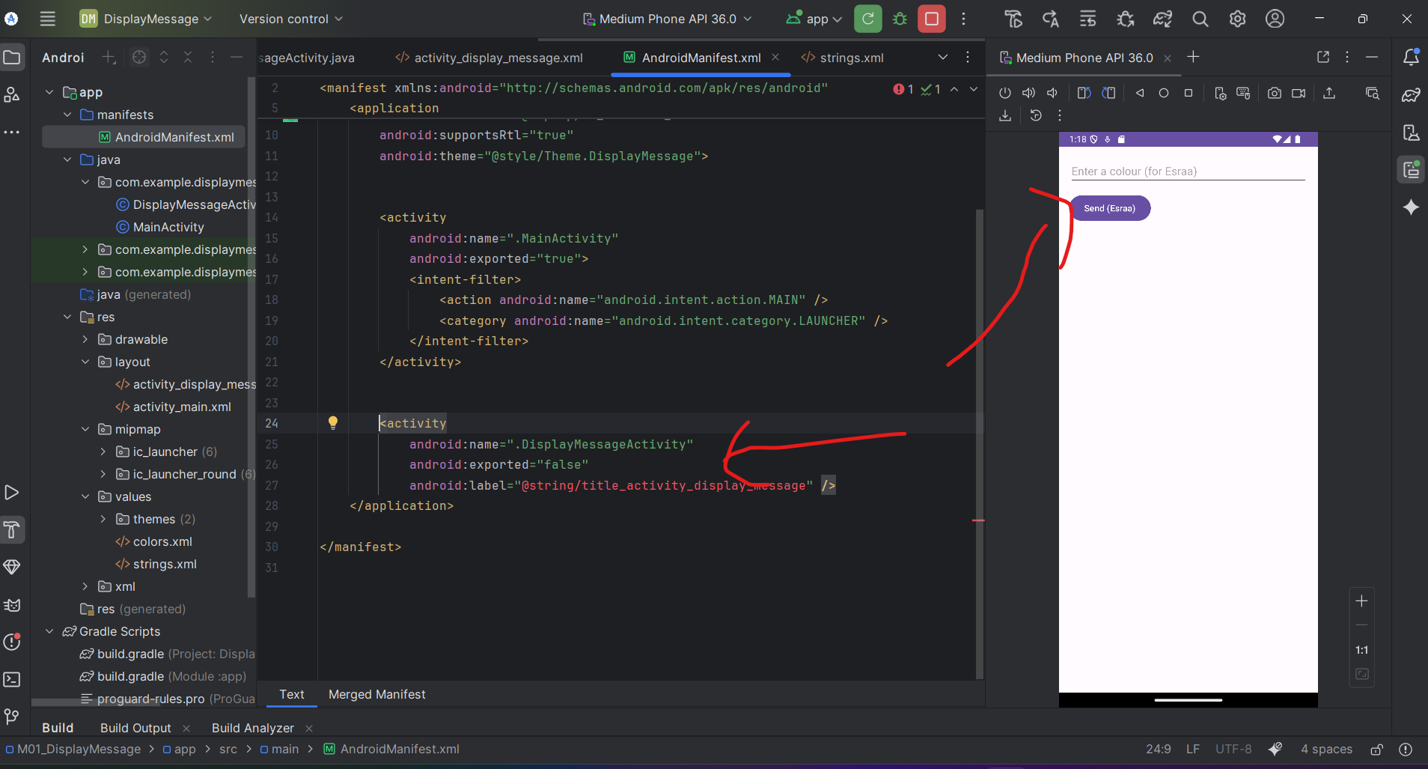

1. **Change the hint text from "Enter a colour" to something with your name in it ("Enter message to Russ").**

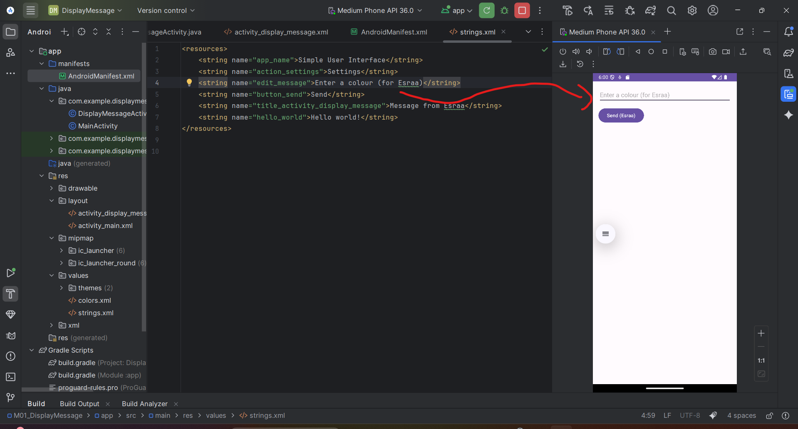

1. **Change the name of the 2nd activity from "DisplayMessageActivity" to something with your name in it. (use strings.xml file)**

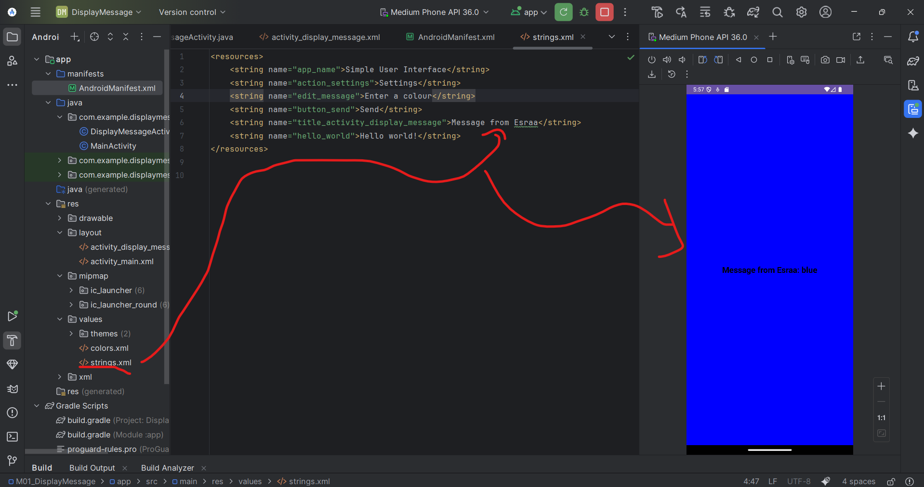

**Part 2: Mo1- Calculator**: Here is my Github URL: <https://github.com/EsraaAbdelmoein/Android--Calculator.git>

Activity_main.xml layout:

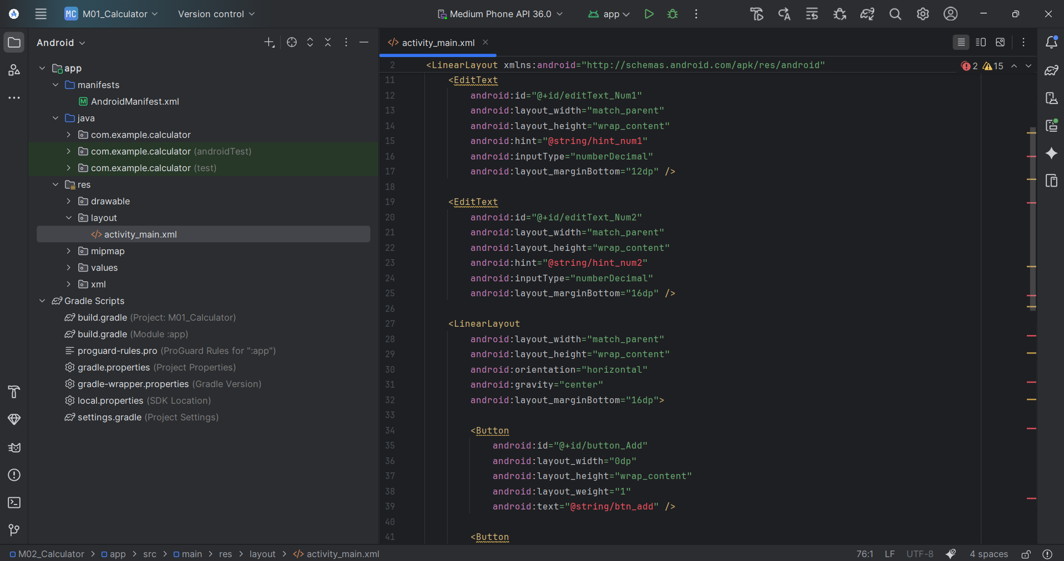

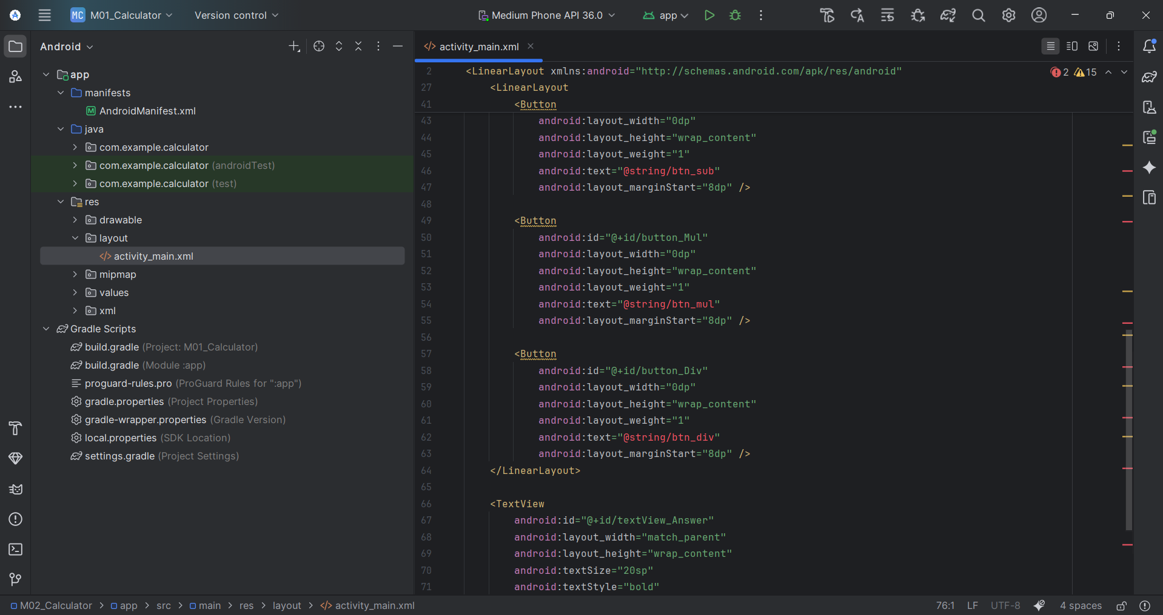

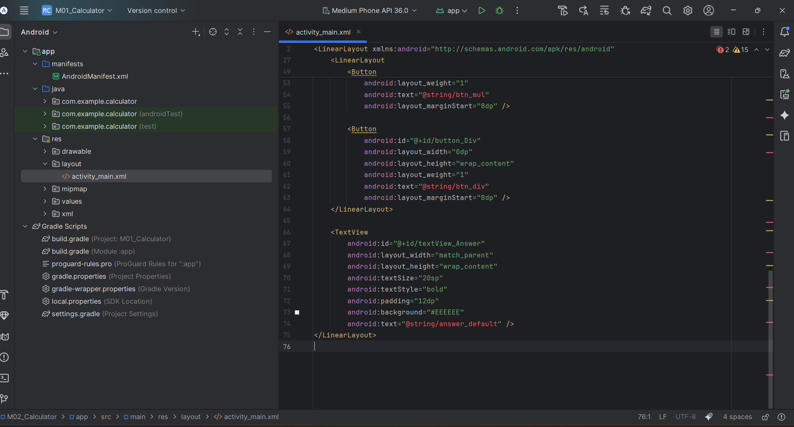

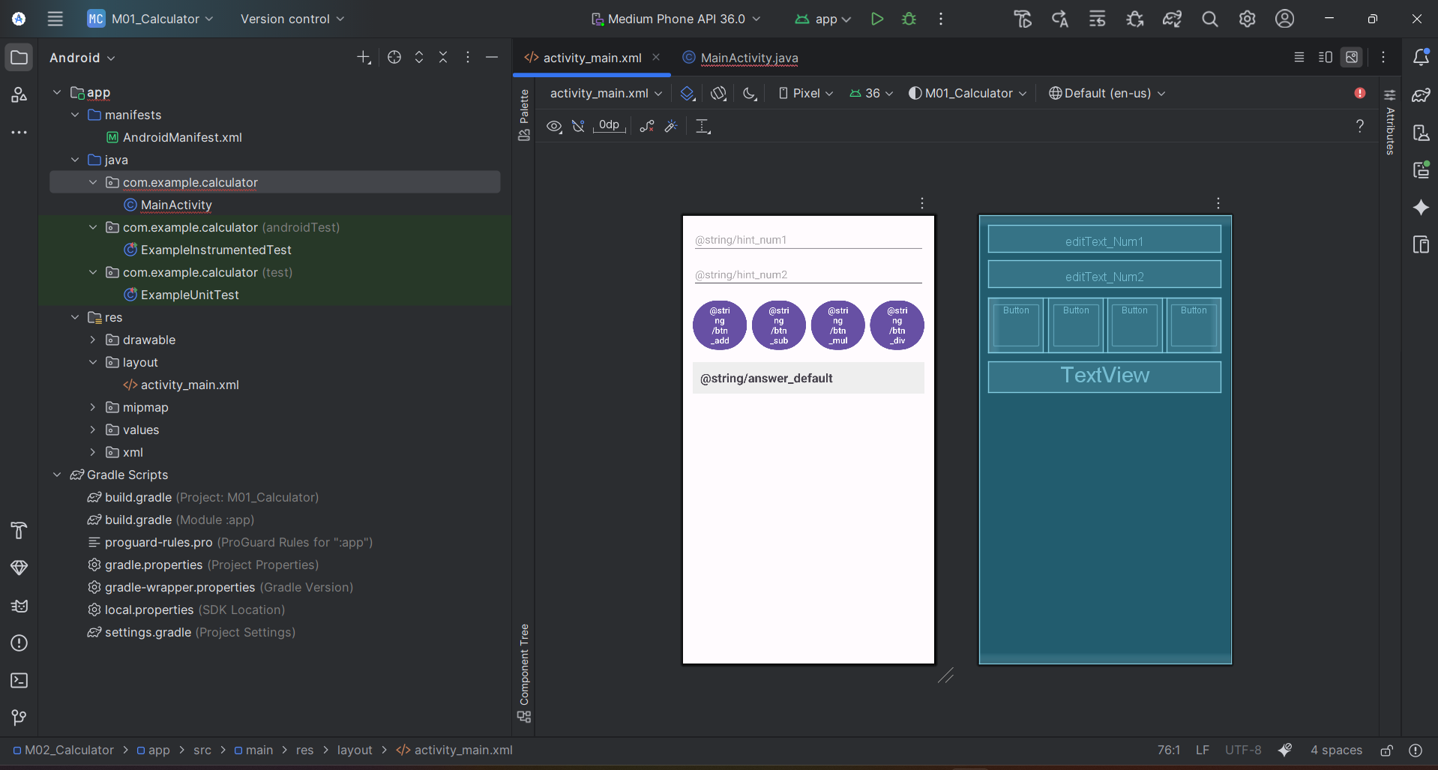

MainActivity.java code:

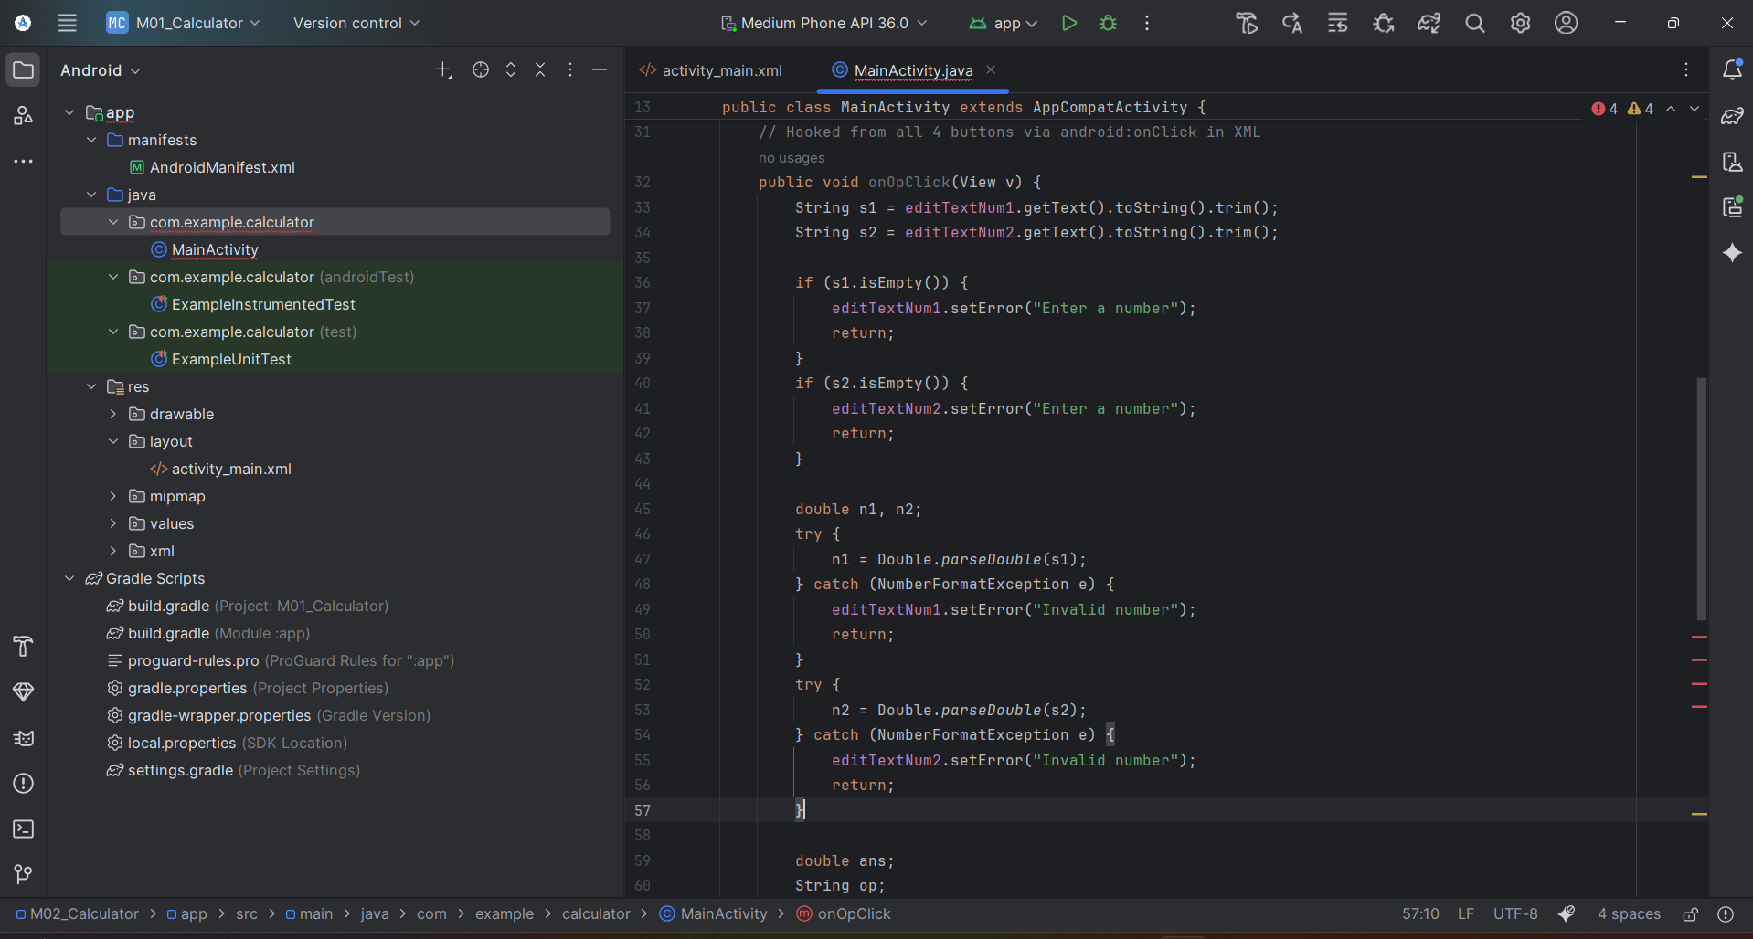

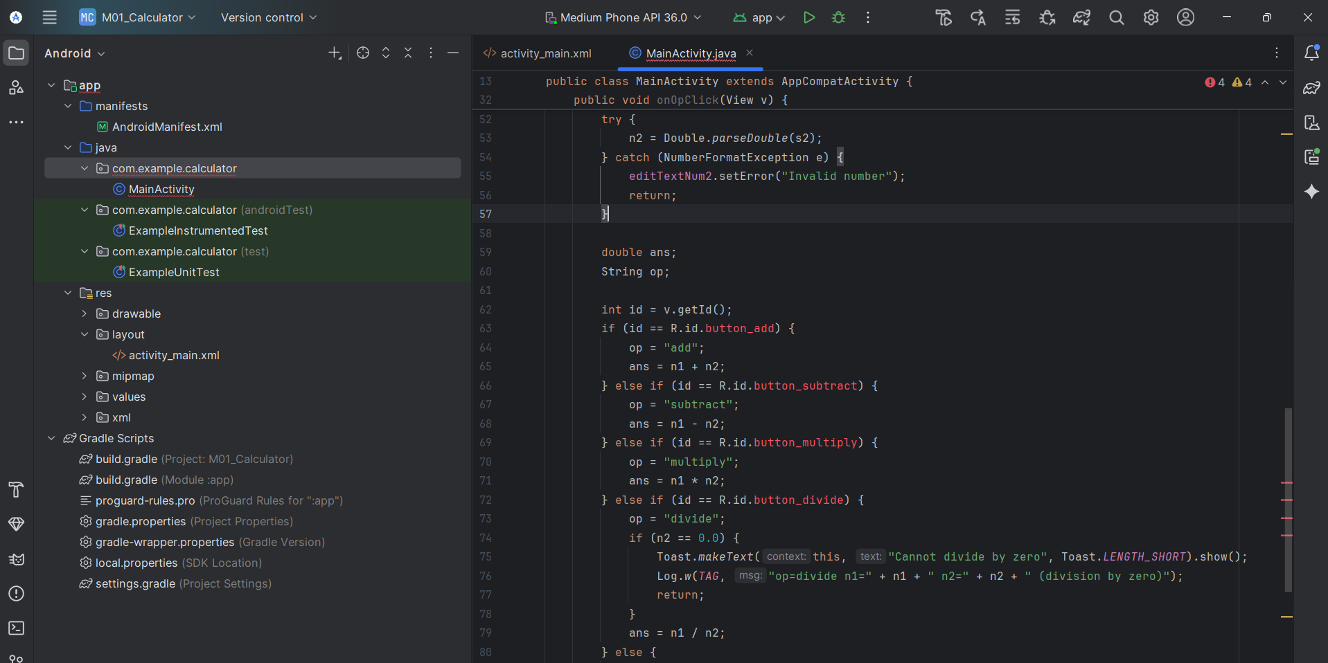

App running in Emulator:

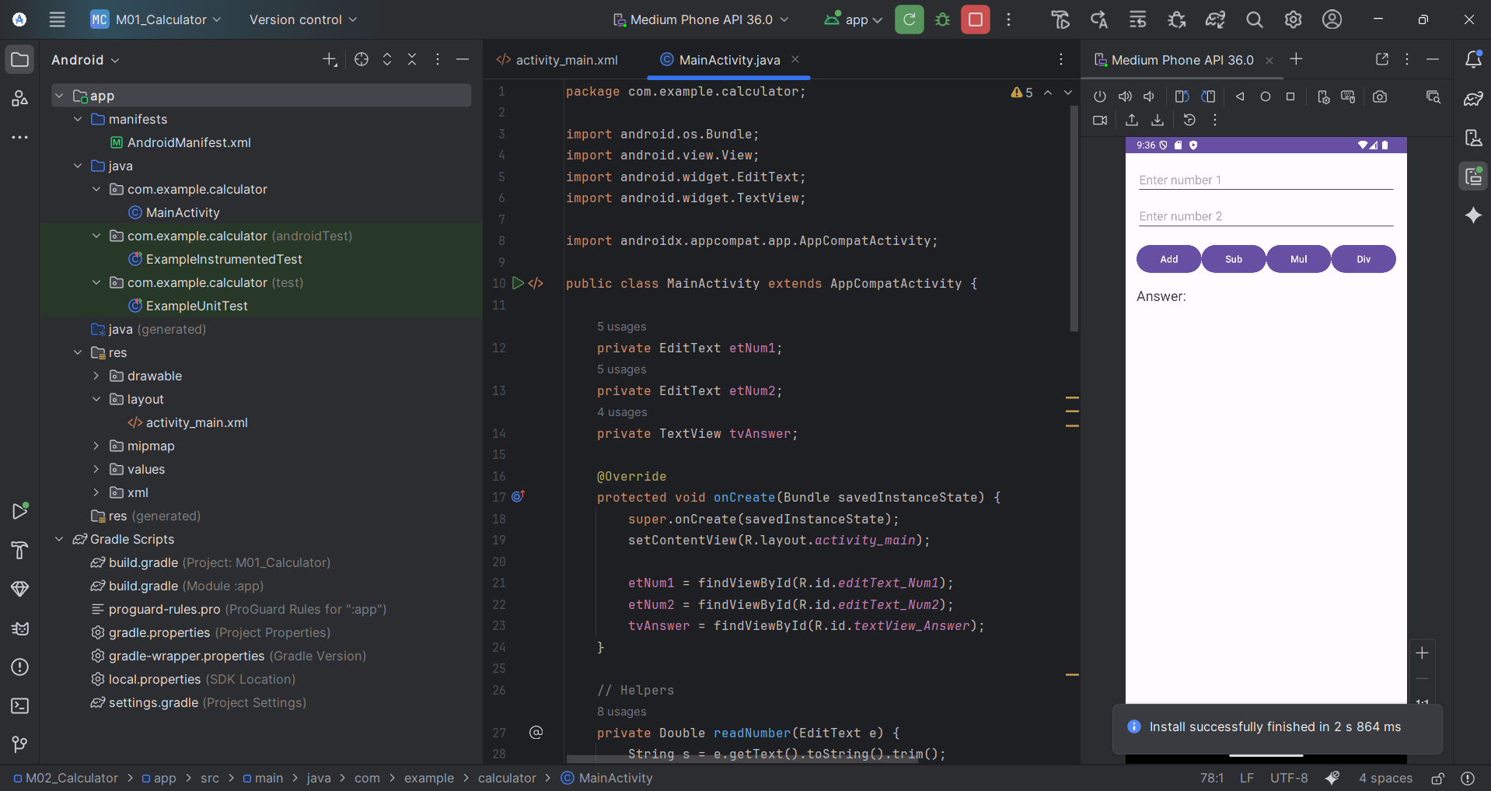

Addition Example:

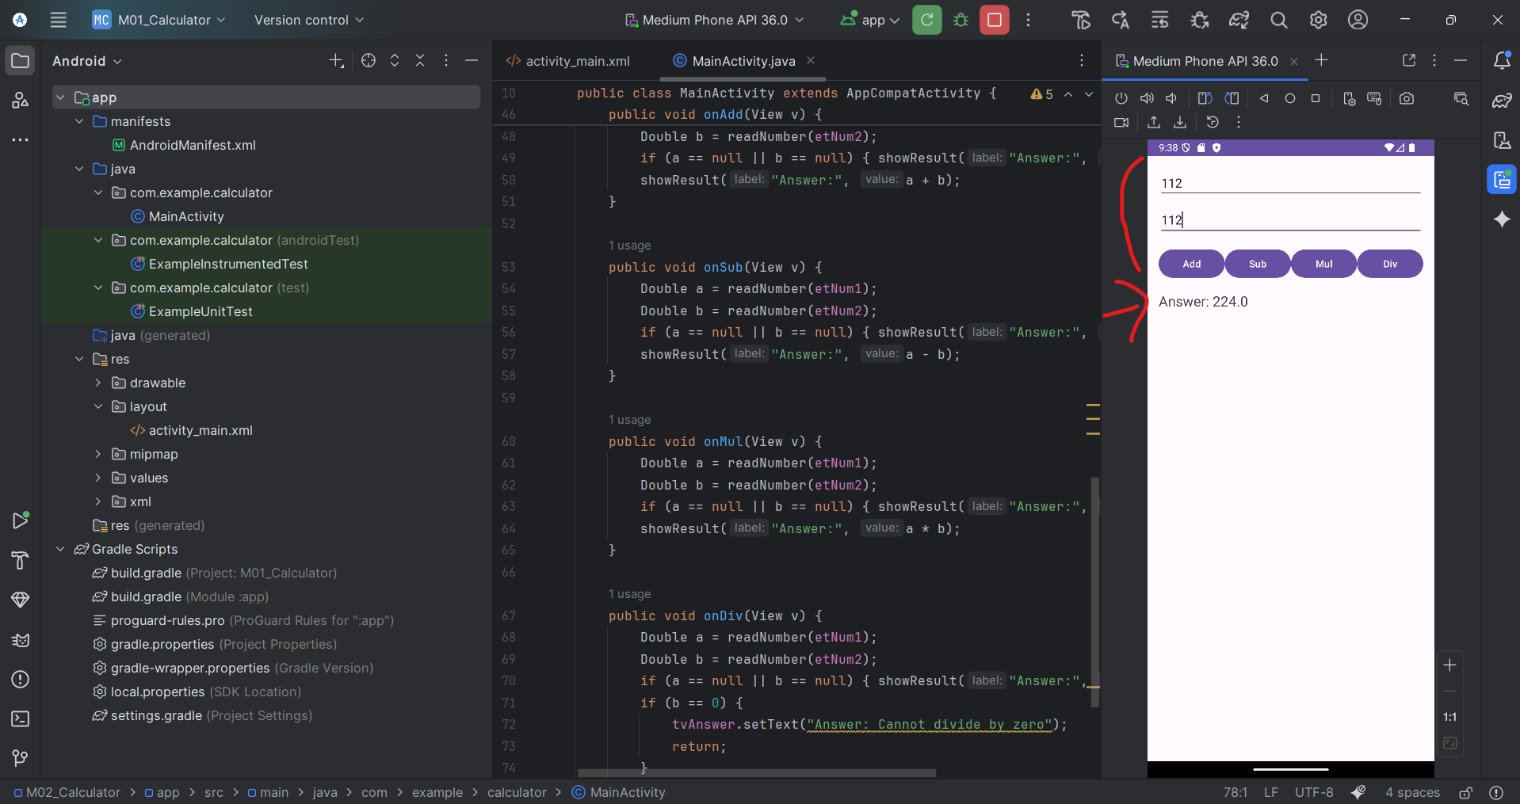

Subtract Example:

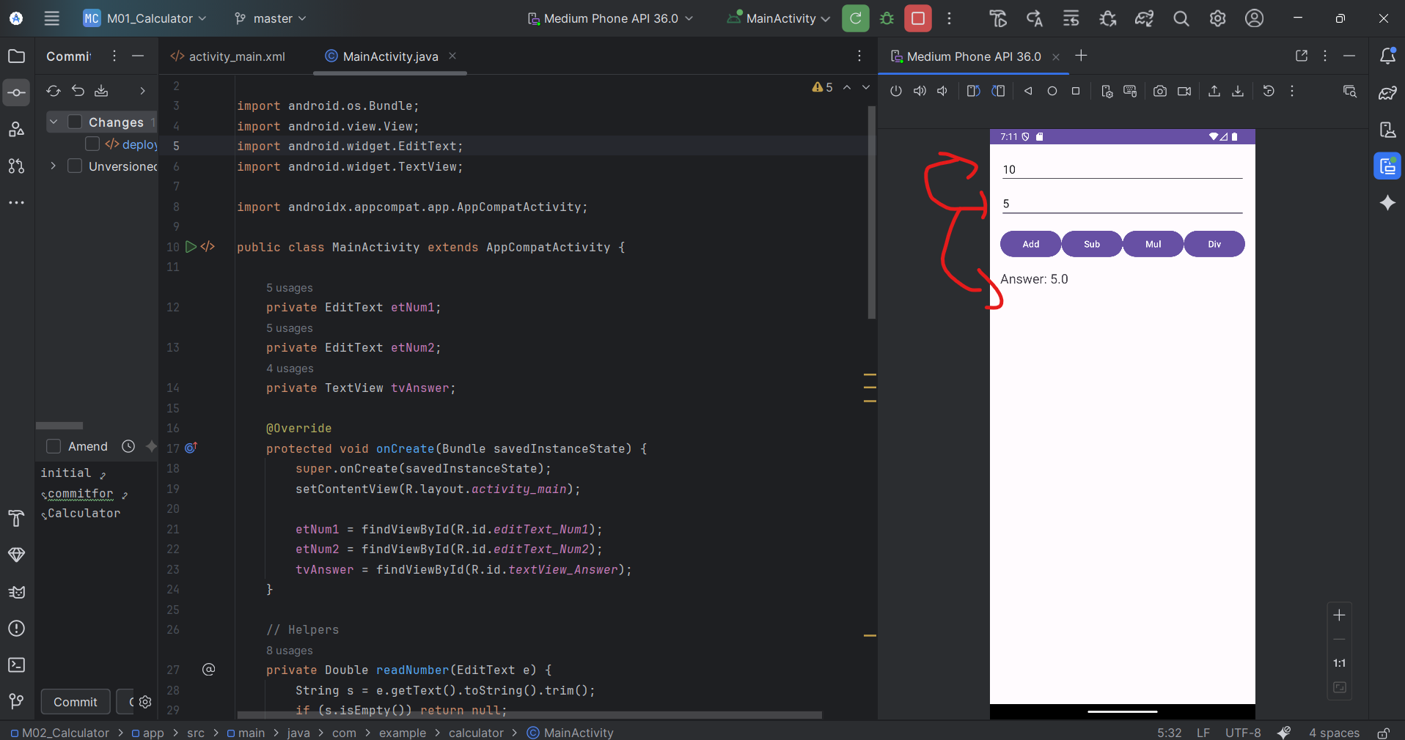

Multiplication Example:

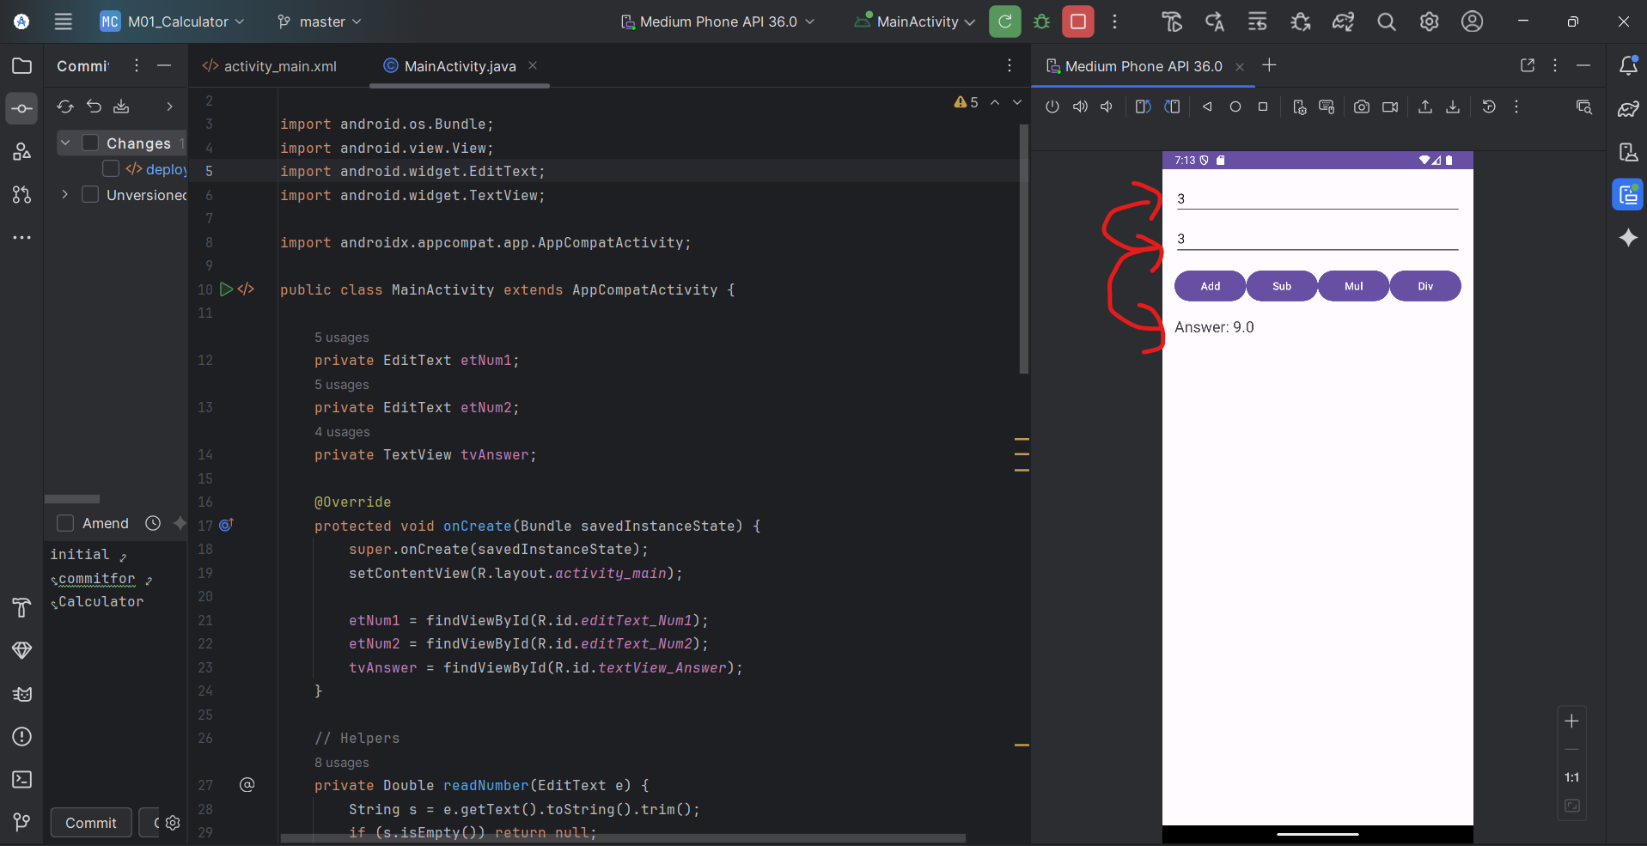

Division Example:

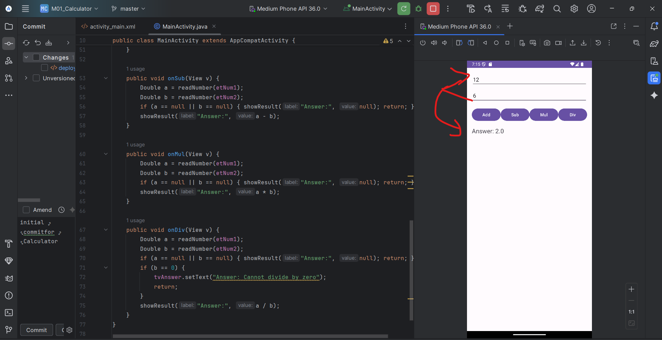

If we try to divide by Zero it cannot divide:

